**WHATSAPP PAY**

**Project submitted to: Project Submitted by:**

**Simplilearn For CBAP Rajachandra Shekar Reddy Naru**

**CONTENTS**

1. **INTRODUCTION………………………………………………………………………..3**
2. **STAKEHOLDERS…………………………………………………………………………4**
3. **RISK IDENTIFICATION FOR WHATSAPP PAY……………………………….4**
4. **SWOT ANANLYSIS OF WHATSAPP PAY………………………………….…..5**
5. **TRANSITION STATE OF WHATSAPP PAY………………………………..…..6**
6. **AS-IS STATE PROCESS MAP OF WHATSAPP PAY…………………………7**
7. **FUTURE STATE PROCESS MAP OF WHATSAPP PAY……………….…...8**
8. **SCOPE USING CONTEXT DIAGRAM………………………………………..……9**
9. **MAIN FEATURES NEED TO BE DEVELOPED………………………………..10**
10. **IN SCOPE AND OUT OF SCOPE REQUIREMENTS…………………………10**
11. **BUSINESS REQUIREMENTS………………………………………………………..11**
12. **FUNCTIONAL AND NON-FUNCTIONAL REQUIREMENTS…………..…11**
13. **SCREEN FRAMES………………………………………………………………………..12**

**INTRODUCTION:**

WhatsApp is the one of the world’s biggest Instant Messaging (IM) and Voice over IP (VoIP) companies owned by Facebook. It was founded in February 2009. This application can be downloaded in mobile phones through both Apple store and Play store and this can also be accessed in laptops and desktop computers. This allows its users to send and receive text messages and voice messages and also make voice and video calls. Along with that WhatsApp also facilitates its users to send documents, images and other files. It serves as the main source of electronic communication in all the countries across Asia, Africa, Latin America and Europe with more than 2 billion users.

In recent times people across the continents are moving towards seamless digital payment applications like PayPal, Google Pay. These digital payment applications are in huge demand due to increase in usage. The transaction value of payments done through mobile wallets will be growing exponentially in coming years.

WhatsApp being the largest messaging company wanted to invest in digital payments which allows its 2 billion users to allow transactions between peers, family and family through new feature called WhatsApp Pay. It aims to take a big share in digital payments carried out across the world.

It initiated its new payment feature as an update to the existing messaging application in Brazil to test its compatibility and modify it according to the feedback which can cater large markets like India and other countries across the continents. It aims to be leading digital payments application based on its high popularity and large 2 billion user base spread across the globe.

**STAKEHOLDERS:**

|  |  |
| --- | --- |
| **ACTOR** | **What he can do on the Software Created** |
| WhatsApp users | * WhatsApp users can link their credit or debit card to their WhatsApp pay * Users can be able to send or receive money through WhatsApp pay * They can also request money from their contacts through WhatsApp |
| Banks | * Banks must register their banks in WhatsApp and authorize WhatsApp pay services which allows WhatsApp pay users to link their bank details to WhatsApp and transfer money |
| Credit card providers | * Credit card providers must register with WhatsApp pay and allow their customers to add credit card to WhatsApp pay and authorise transactions from the app * This allows WhatsApp users to move money within their credit limit |
| Bank (debit card provider) | * Debit card providers must allow WhatsApp users to link their debit card details to make transactions through WhatsApp pay |

**RISK IDENTIFICATION USING MIND MAPPING TECHNIQUE:**

**SWOT ANALYSIS OF WHATSAPP PAY:**

**WEAKNESSES**

Heavy competition in the market

Less need for new payment wallet from the audience

**SRENGTHS**

2 billion satisfied users of WhatsApp can be potential users of WhatsApp Pay

Strong brand value of WhatsApp

**THREATS**

Security risks to the users

May increase the risk of scammers directly sending links to WhatsApp requesting money

**OPPORTUNITIES**

Can capture a big share in digital wallet market

Can achieve high profits in less time

Can attract new customers with this feature

**TRANSITION STATE OF WHATSAPP PAY:**

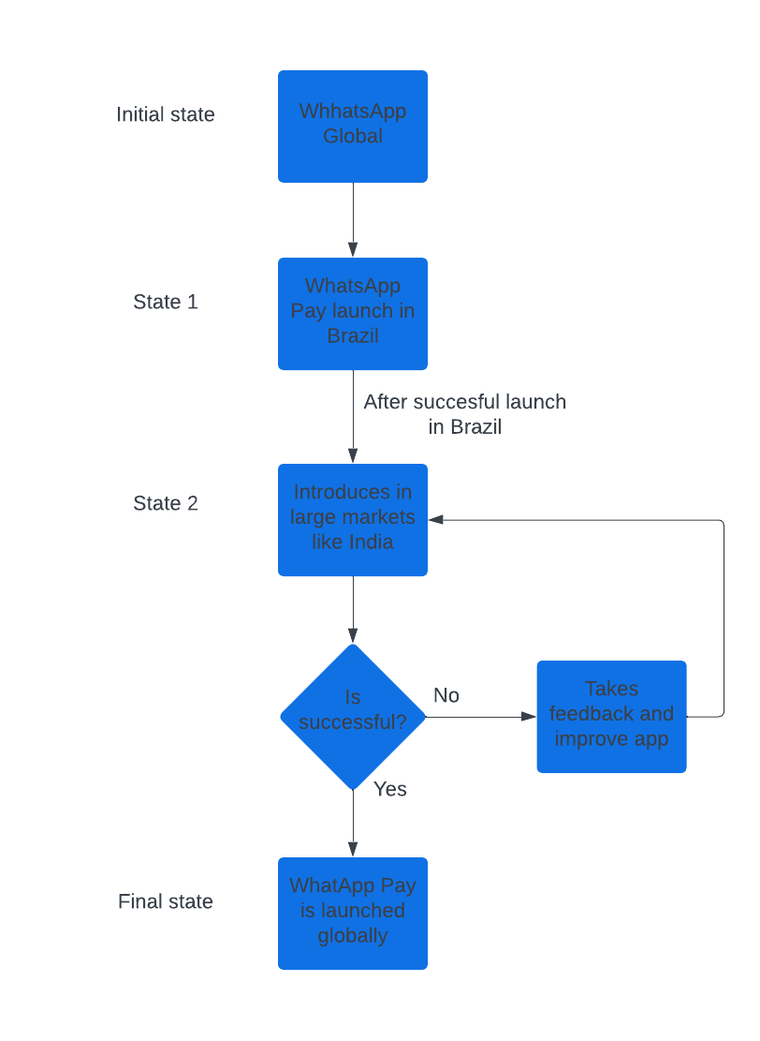

**AS- IS STATE OF WHATSAPP****:**

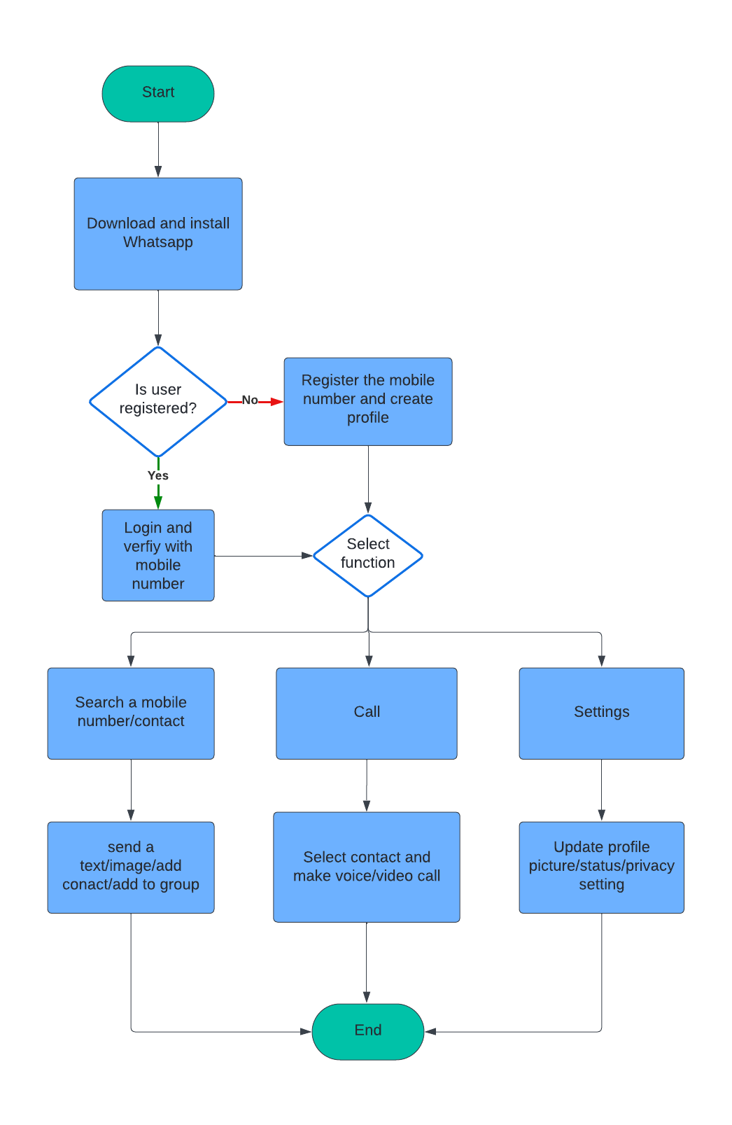

**FUTURE STATE OF WHATSAPP PAY:**

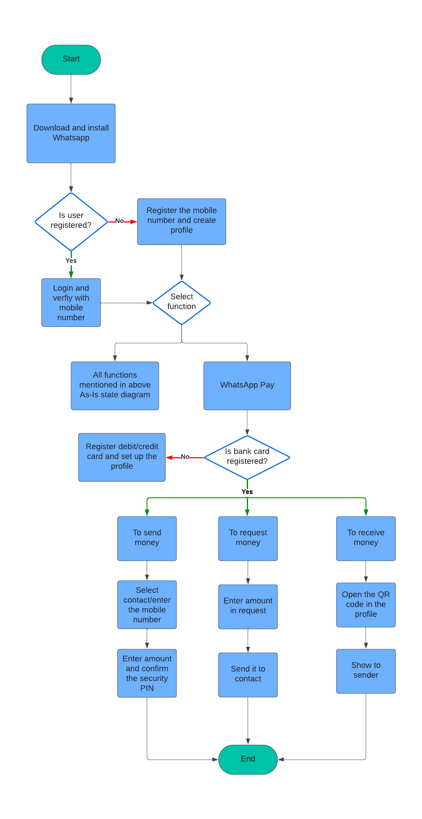

**SCOPE USING USE CASE DIAGRAM (UML):**

Confirm transaction User requests money to one ofcontact

WhatsApp Pay users

(Sender)

WhatsApp Pay users

(Receivers)

User attempts to send money Transaction update

Approve/reject

Banks

Customer service

Approves trasfer money Users ask for help

User verification Customer service

replies to the user

User verfied

**MAIN FEATURES TO BE DEVELOPED:**

* WhatsApp payment interface should be created which facilitates peer to peer transactions without exiting WhatsApp application
* It should allow users to transfer money to friends, family or relatives and other contacts
* The interface should facilitate one-click payments
* It also should have QR code scan functionality to receive money through the new feature
* Users should not be needed to visit banks, other digital wallets or bank applications to send and receive money
* This interface should be very easy to use and make digital payments seamless without entering details in multiple page loads

**IN SCOPE REQUIREMENTS:**

* WhatsApp need to have login/register tab for WhatsApp pay feature to add bank cards
* WhatsApp should send/ receiving notifications to mobile phone when the transaction is done
* It should have history payments page to see previous transactions
* It needs to show feedback option after each transaction
* It should also have a customer service number and mail address in help page
* In order to finish transaction, it should ask for a security PIN every time
* WhatsApp pay should be linked with Bank servers
* It should be available in different languages

**OUT OF SCOPE REQUIREMENTS:**

* WhatsApp pay feature can only be used by WhatsApp users
* Users need to link bank debit/credit cards to use the WhatsApp Pay
* Existing WhatsApp users can only use WhatsApp pay feature if they have updated the new version of WhatsApp

**BUSINESS REQUIREMENTS:**

**BUSINESS OBJECTIVES:**

* At least one million users should use the WhatsApp pay feature by first three months from its release
* By one year of its launch around 30% of WhatsApp users should use the WhatsApp pay feature

**FUNCTIONAL REQUIREMENTS**

* Bank debit/credit cards should be linked to WhatsApp to make transactions
* WhatsApp should have login/register option for WhatsApp pay feature to add debit cards
* It should be able to send/ receive notifications to mobile phone when a transaction is made
* It should have payments history tab to see previous transactions
* It should have feedback option after each transaction
* It should also have a customer service number and mail address under Contact us tab

**NON-FUNCTIONAL REQUIREMENTS**

**SYSTEM REQUIREMENTS:**

WhatsApp should launch this new feature in one country at the first to test and get the user feedback. Later, it should release WhatsApp pay feature in another big market like India and the rest of the countries in the world

**USABILITY:**

User interface of the WhatsApp pay feature should be very easy to use and self-explanatory for the users

**SCREEN FRAMES:**

